* **Veterans Day (11/11/22)**
* **We invite family and friends to our Harvest Celebration on (11/16/22)**

# Reminders

As the weather is changing we encourage our family to dress your child appropriate for the weather. Everything you do bring in, please make sure it is labeled with their name.

**La’vante 11-1**

**Amire 11-8**

**Joseph 11-10**

**Amayia 11-15**

**Liam 11-25**

**Ms. Marjorie 11-20**

**M**

# Upcoming events

**November News**

**This month our classrooms will be focusing:**

* **Changing Weather**
* **Children will have fun with pumpkins, explore what’s inside, measure the size of pumpkins and taste food made from pumpkin.**
* **Leaves color change, vegetables and harvest.**
* **Childrin will be learning about Community Helpers, Family and been Thankfull for.**

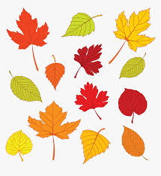

### Newsletter

Springfield

November

2022

# Happy Birthday!!!!MC900412432[1]

**It is important to always keep your child(ren)’s information updated. I will be contacting parents for any paper work as needed.**

# From the office

# Center Happenings

